**Gaming Store Inventory Management System**

**Instructions to run the project:**

1. Database is on xampp, so you must open xampp and import database. Database file is given in the google classroom portal.
2. Run xampp and run the project. The password for admin is OOPProject. The password for employee is given in the database also the email too.

**About Project:**

1. This is an inventory system which adds, stores, deletes products, and gives admin employee management power. Moreover, we have a simple static look for the user website in the user login panes you can login and check how the website will look.
2. The admin has Settings that can manage and view all Employees Data.

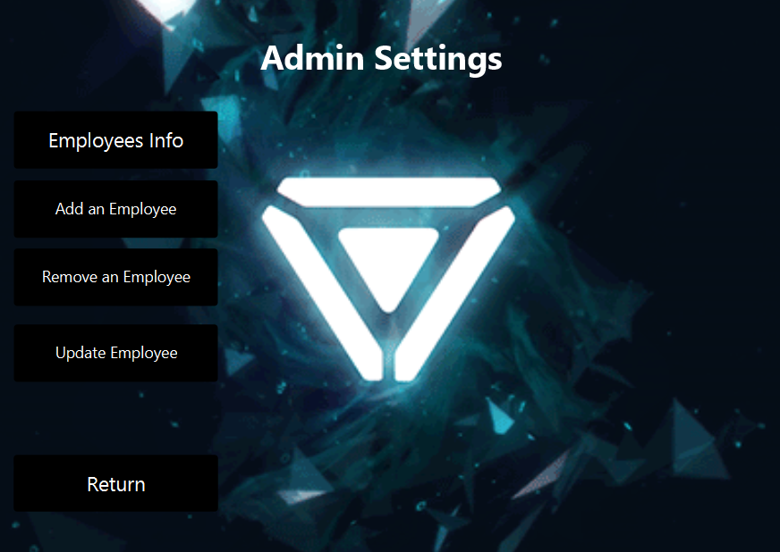

1. The add/delete/Update products buttons are given in the All page of the project which consists of a scroll pane. You can scroll to view the buttons.

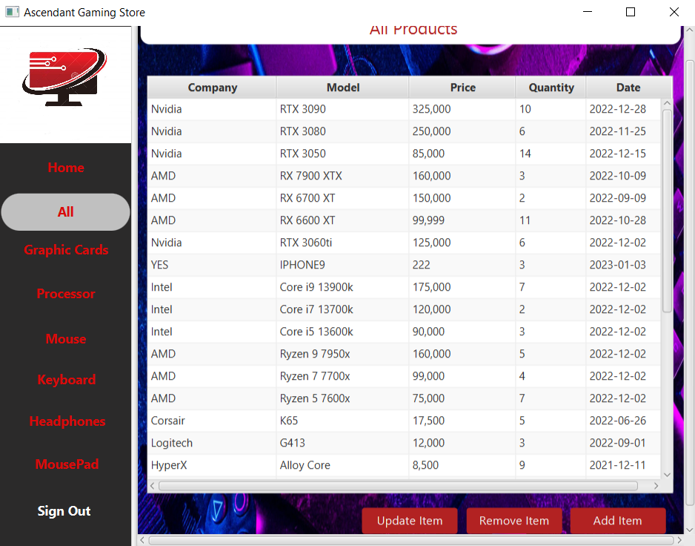

1. All the addition/remove of data has complete validations on the fields where required.
2. Moreover, all the Products Tables are dynamic. You can add image by giving the image path.

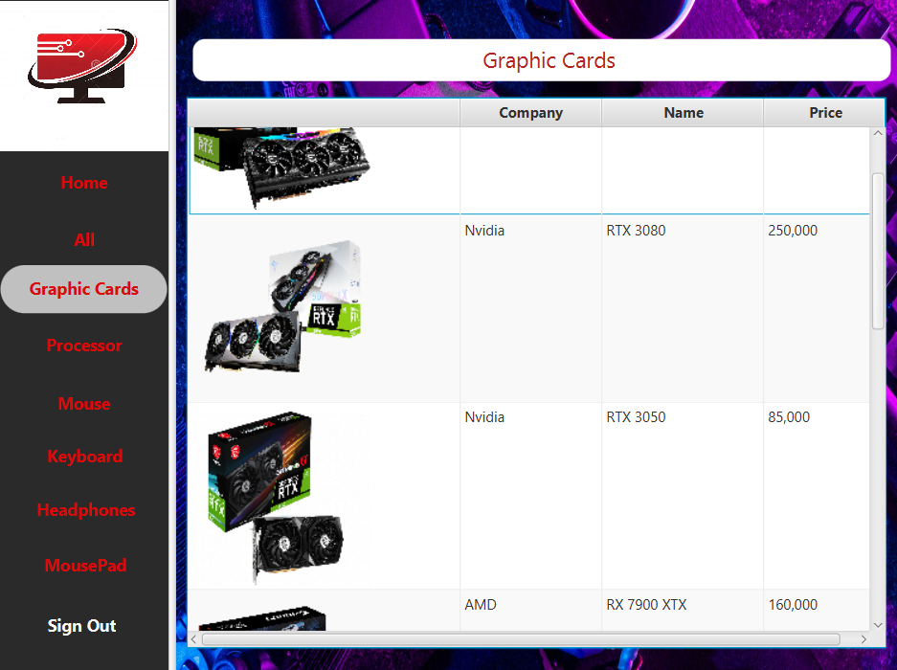

1. Employee side can view all the orders from the order database. He can also change its Password from the settings tab.

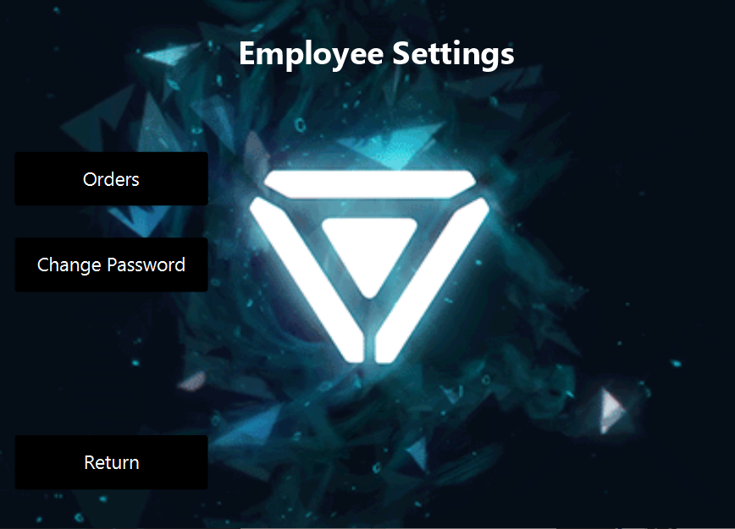

1. The reporting functions are available for both admin and the employee to view from the home tab.

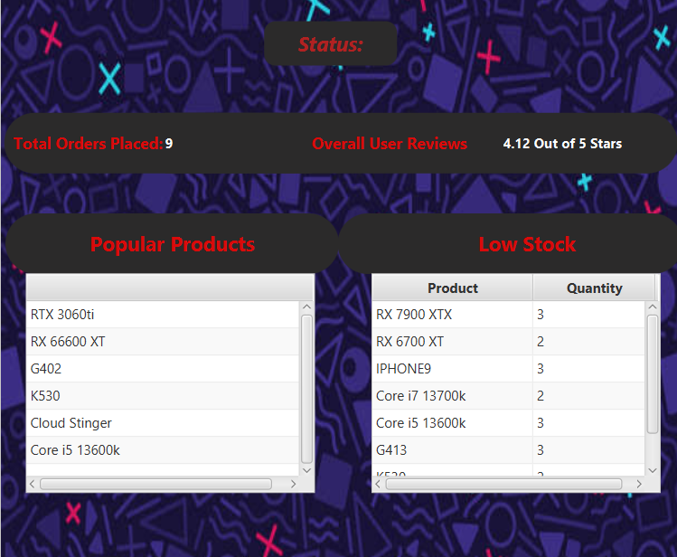

jbbjhboi